VISHAAL SV 192412349
ECA0502 EMF

EXP 6
Determination and plotting of Capacitance of parallel plate capacitor in three different dielectric medium with specific area, dielectric thickness and various dielectric constant. PROGRAM:
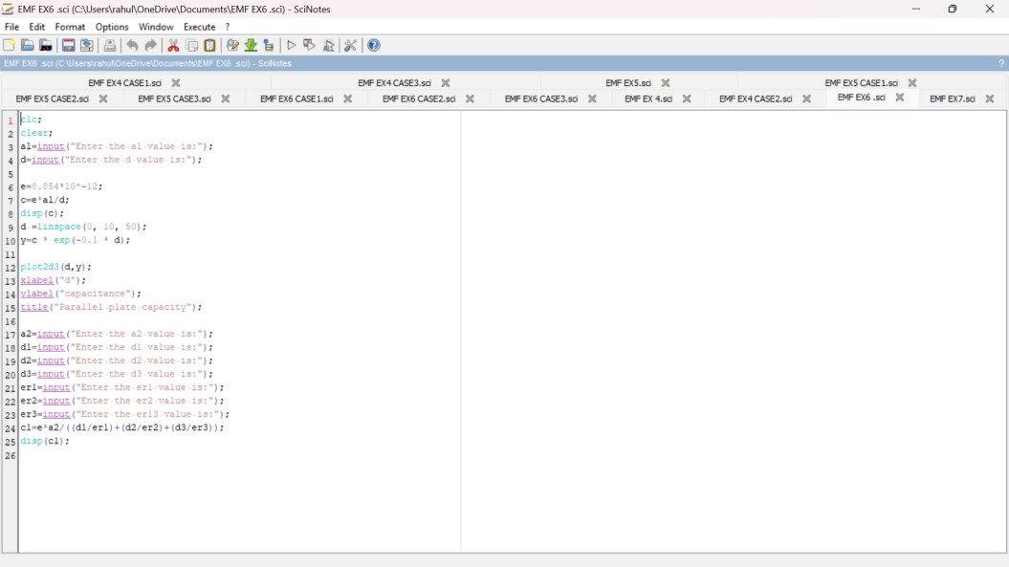
OUTPUT:
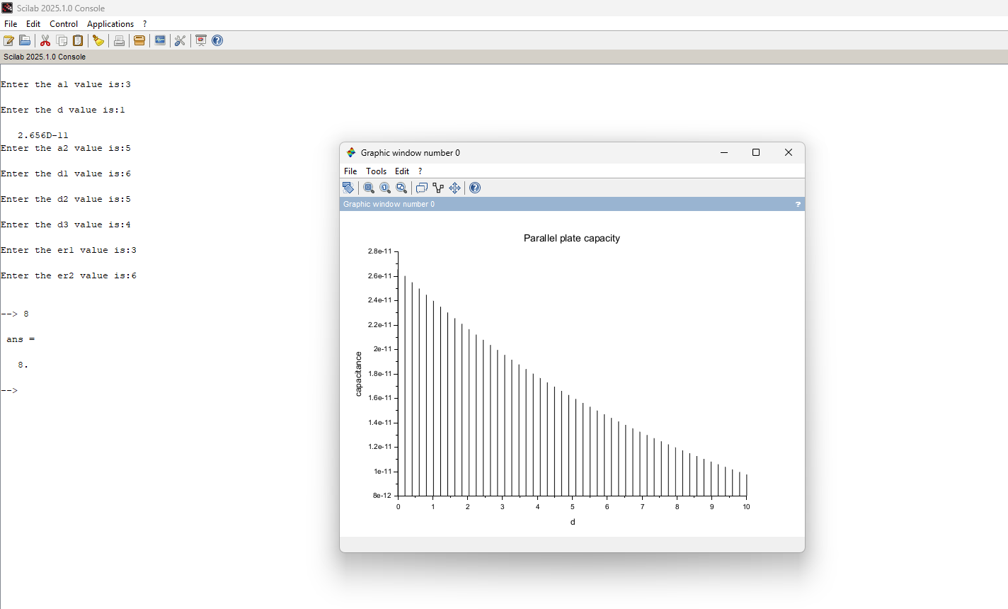

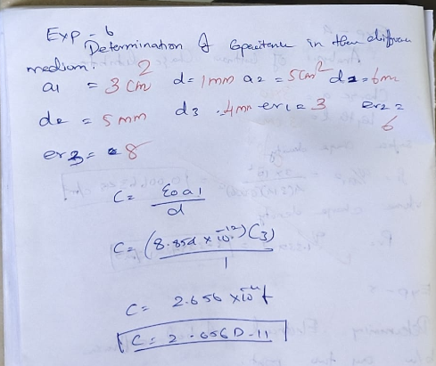
CASE 1:
PROGRAM AND OUTPUT:

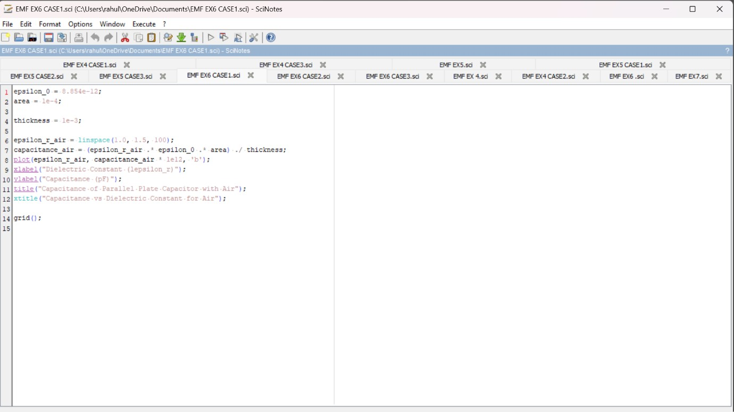
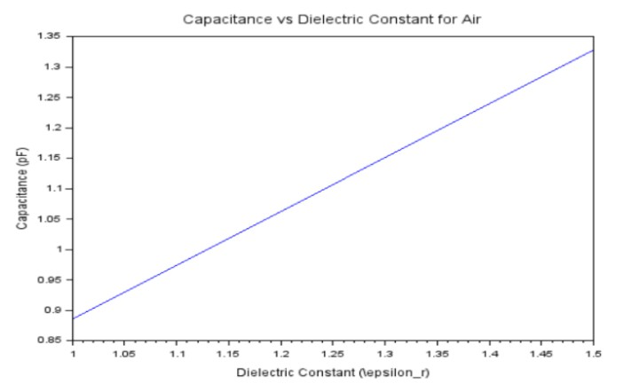

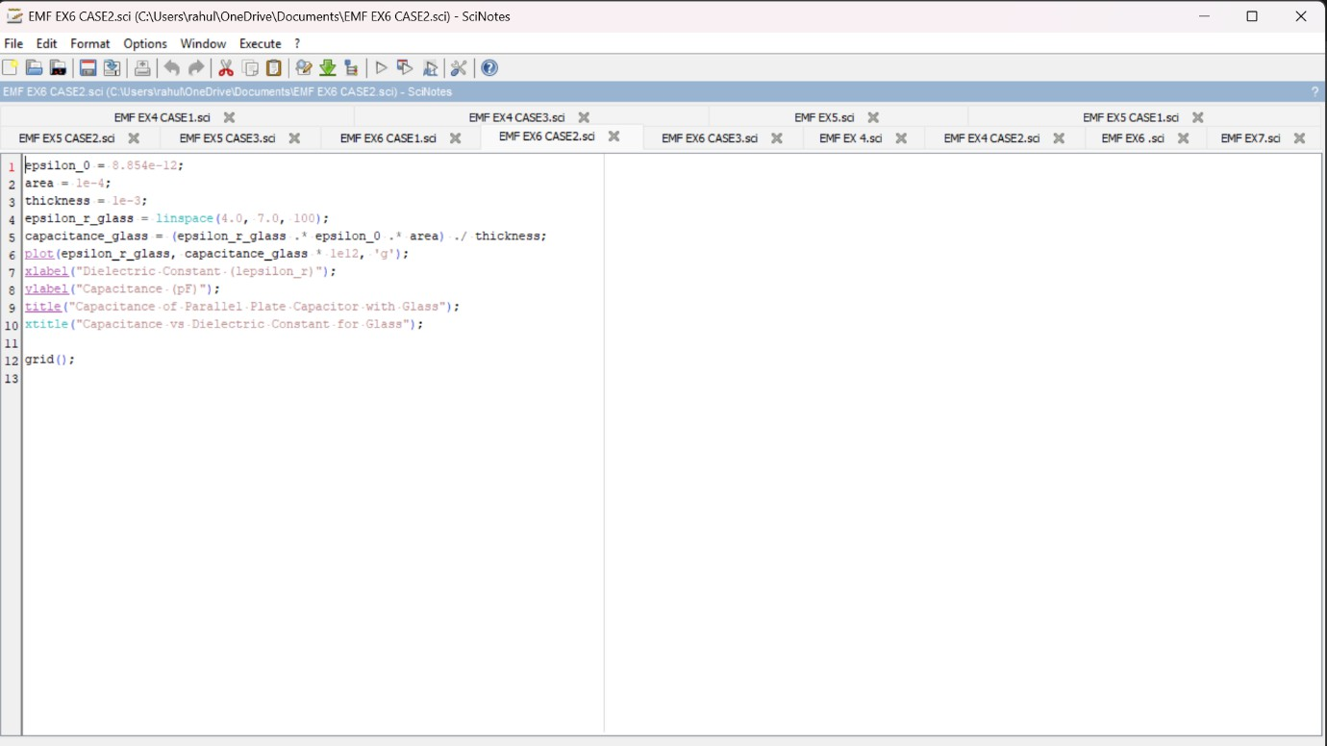
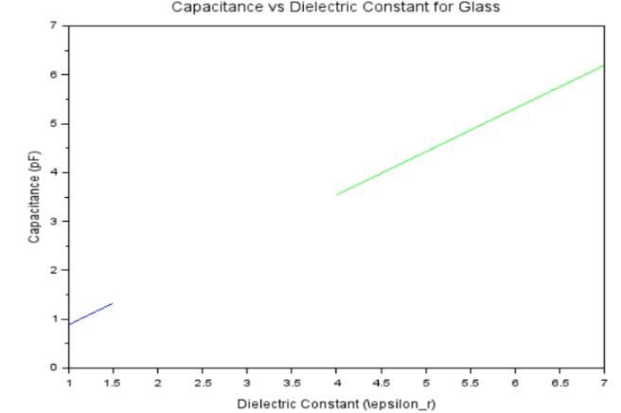
CASE 2:PROGRAM AND OUTPUT:

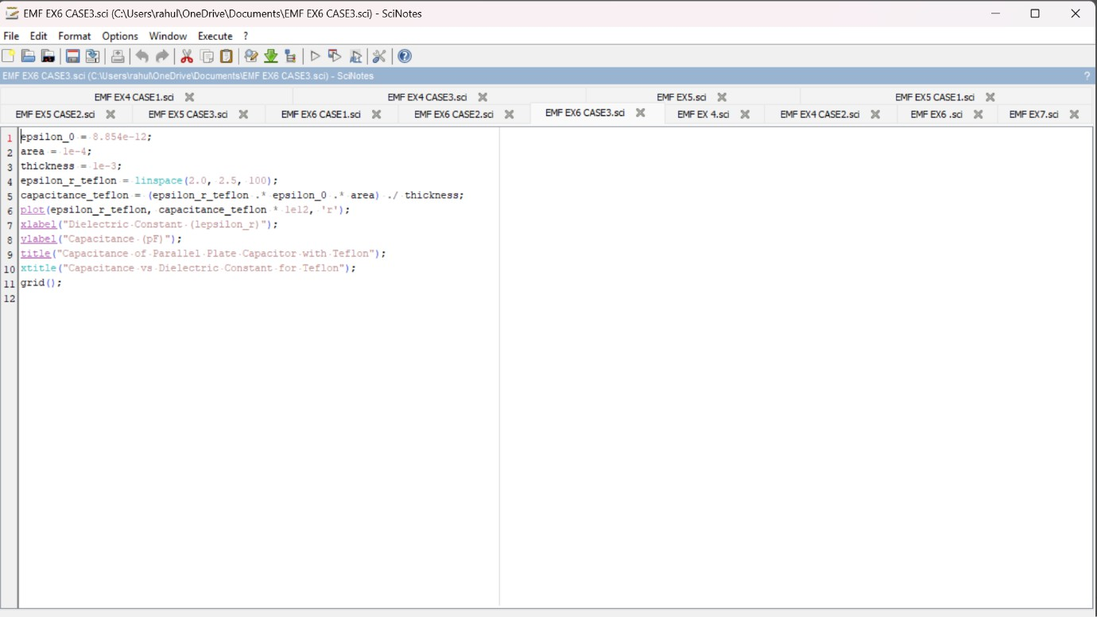
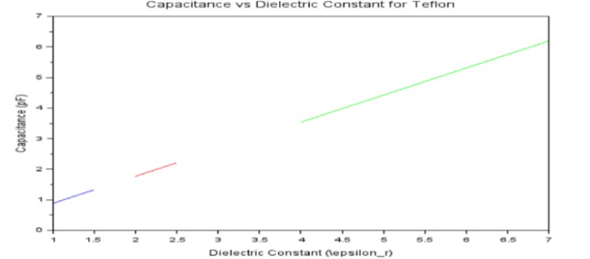
CASE 3:
PROGRAM AND OUTPUT

